**Install Python packages (3 ways)**

Author: Kai-Tao Yang ([k.t.yang@uvt.nl](mailto:k.t.yang@uvt.nl)), Data Engineer at JADS

# Anaconda Navigator => Environments

As shown in the following figure, open **Anaconda Navigator**, click **Environments**, select **Not installed**, type in the packageName (e.g., mysql). If the package is available, then check and install it. Otherwise, please go the second and third methods in the following section.

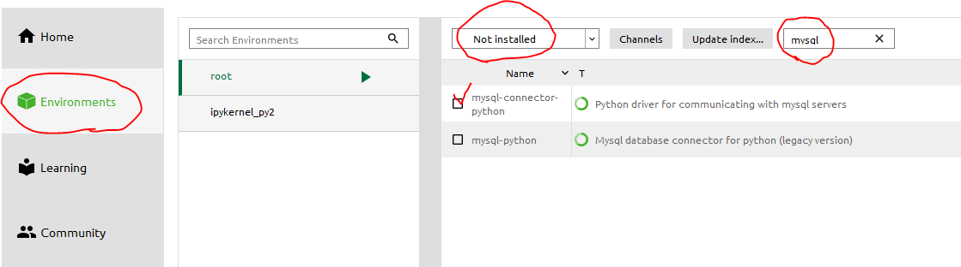

# Run the following command in a terminal (run as administrator):

pip install packageName

or

conda install packageName

# Unofficial Windows Binaries for Python Extension Packages (only for windows users)

Go to this website: <http://www.lfd.uci.edu/~gohlke/pythonlibs/>

Download the packageName.whl file (please choose the right version), and run the following command in the terminal:

pip install directory/to/the/packageName.whl

**Note**: please replace "packageName" with the actual name, and replace "directory/to/the/" with the actual directory.